The Original Thirst Quencher

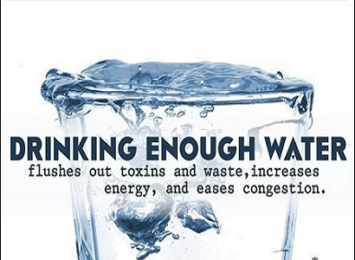

When was the last time you drank a glass of water?
​
As silly a question as that may be, water often isn’t the first beverage chosen when a person is thirsty. Many stop during their busy day for a quick coffee or sugary drink. For birthday parties, one can find several 2 litre bottles of soft drinks. Even the non-carbonated beverage drinkers may first pour themselves a glass of fruit juice instead of water. Athletes often look to Powerade, and other sports drinks to quench their thirst.
​

High Road Chiropractic Centre asks: Why is water often neglected?

​
One reason is many of these other drinks contain sugar and artificial sweeteners. Water does not; so people may find themselves looking for that sugar rush. Some might consider water a boring drink, while other drinks “taste better” and are more associated with party foods and memories.
​
Water is essential to your health. Your body is made up of 85-90% water, so it makes sense to replenish the body with something it needs naturally. Water also provides your body with essential nutrients in order for you to stay hydrated and healthy. Staying hydrated with water assists your spine and your spinal discs to maintain proper movement and function. Your muscles and joints also benefit from water.
​
Generally, drinking eight glasses of water throughout the day is recommended to stay properly hydrated, depending on the individual.

Consult High Road Chiropractic Centre today about how you can drink more water to gain greater health.

